26th September 2014

**YOKOHAMA Releases “CSR Report 2014”**

Tokyo – The Yokohama Rubber Co., Ltd., announced today that it released its English-language “CSR Report 2014” on 11th September. The 32-page report presents the Yokohama Rubber Group’s CSR activities. The report’s web version (GRI Guidelines Application Level B), providing even more comprehensive coverage of Group CSR activities, is scheduled to be available in the middle of December. The Japanese version of "CSR Report 2014" was released at the end of May, and the Web version was posted to the Company's website in early September.

The Yokohama Rubber Group is promoting CSR activities in keeping with its medium-term theme of “protecting the environment and people around the world”. “CSR Report 2014” introduces the Group’s views about this theme and the specific actions it is undertaking. The report is broadly divided into four sections: “For 2017 and Beyond”, “Yokohama Rubber’s Growth Strategy for 2017”, “Yokohama Rubber Group’s CSR”, and “Seven Pillars of Core Subjects for Yokohama Rubber to Address”.

In “For 2017 and Beyond”, the report presents a discussion between Yokohama Rubber President Hikomitsu Noji and the company’s CSR director with three external experts from different fields. The discussion centres on how YOKOHAMA should use its position as a multinational corporation to contribute to the global society in the next few years leading to the company’ s centennial in 2017 and then beyond.

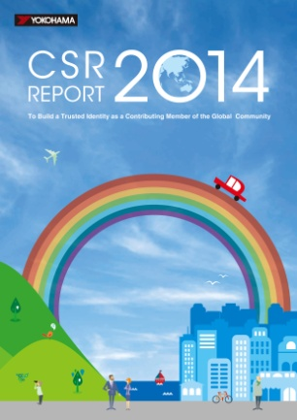

*Cover of Yokohama Rubber Group’s “CSR Report 2014”*

The section on “Yokohama Rubber’s Growth Strategy for 2017” introduces Grand Design 100 (GD100), the medium-term plan guiding the Group up through its centennial year in 2017. The section presents the plan’s goals, including numerical targets, and some of the specific actions being taken by each division to realize these goals while also prioritizing its relationship with society.

“Yokohama Rubber Group’s CSR” explains the Group’s basic corporate philosophy on CSR and introduces its preparations for compliance with the call for “disclosure of information that focuses on important issues (material aspects)” in GRI Guidelines Version 4 (G4), announced in May 2013.

Finally, the section on “Seven Pillars of Core Subjects for Yokohama Rubber to Address” details the progress of the action plans being implemented to ensure compliance with ISO26000 standards. The section includes reports on the current status of each action plan from the individuals responsible for the plan’s implementation and outlines the domestic and overseas CSR activities of the Yokohama Rubber Group.